

**CS2031 Computer Networks**

**Publish/Subscribe Protocol**

**Eligijus Skersonas**

**Student ID: 19335661**

# Contents

1. **Introduction 2**
2. **Background 2**
   1. Publish/Subscribe Protocol. . . . . . . . . . . . . . . . . . . . . . . . . . . . . . . . . . . . .2
   2. Datagram Sockets . . . . . . . . . . . . . . . . . . . . . . . . . . . . . . . . . . . . . . . . . . . . . . 3
   3. Datagram Packets. . . . . . . . . . . . . . . . . . . . . . . . . . . . . . . . . . . . . . . . . . . . . 3
3. **Design 4**
   1. Packet Design . . . . . . . . . . . . . . . . . . . . . . . . . . . . . . . . . . . . . . . . . . . . . . . .4
   2. Subscriber . . . . . . . . . . . . . . . . . . . . . . . . . . . . . . . . . . . . . . . . . . . . . . .4
   3. Packet . . . . . . . . . . . . . . . . . . . . . . . . . . . . . . . . . . . . . . . . . . . . . . . . . . . . . . .5
   4. Dashboard/Dashboard2 . . . . . . . . . . . . . . . . . . . . . . . . . . . . . . . . . . . . . . . . . . . . . . . . .8
   5. Broker. . . . . . . . . . . . . . . . . . . . . . . . . . . . . . . . . . . . . . . . . . .9
   6. Sensor1/Sensor2/Sensor3 . . . . . . . . . . . . . . . . . . . . . . . . . . . . . . . . . . . . . . . . . . . . .10
   7. Blinds. . . . . . . . . . . . . . . . . . . . . . . . . . . . . . . . . . . . . . . . . . .11
   8. AC . . . . . . . . . . . . . . . . . . . . . . . . . . . . . . . . . . . . . . . . . . . .13

3.9 DateTime . . . . . . . . . . . . . . . . . . . . . . . . . . . . . . . . . . . . . . 14

3.10 Constants . . . . . . . . . . . . . . . . . . . . . . . . . . . . . . . . . . . . . . 15

3.11 Interface . . . . . . . . . . . . . . . . . . . . . . . . . . . . . . . . . . . . . . . 16

1. **Assumptions 20**
2. **Summary 20**
3. **Reflection 20**

1

# Introduction

This assignment was based on implementing a publish/subscribe protocol using UDP. The assignment included the construction of our own header and the use of datagram packets and sockets. In the process I learnt how to do socket programming and learnt about datagram packets and sockets and how to construct a header.

# Background

## Publish/Subscribe Protocol

The picture above is the topology that I implemented for the assignment.

The Publish/Subscribe Protocol consists of a Publishers, Subscribers and a Broker

**Subscriber:** Can subscribe to a topic

**Subscriber examples:** Dashboard, Dashboard2, Blinds, AC

**Publisher:** Can publish data to a given topic

**Publisher examples:** Dashboard, Dashboard2, Broker, Sensor1, Sensor2, Sensor3, DateTime

**Dashboard/Dashboard2:** User Interface, where a user can either select to publish or subscribe, then the user is prompted to select a topic to publish/subscribe to. If a user is publishing to a topic they are further prompted to enter a command to publish to an actuator (e.g. AC, Blinds). If the user selects to subscribe to a topic then the Dashboard will send a packet to broker indicating in the header that it is subscribing to a given topic and then wait for an ACK and then wait for incoming packets from the topic subscribed to. When dashboard receives a packet it sends back an ACK and then checks if the topic in the header matches what Dashboard subscribed to, if they match the message in the data section of the packet is displayed on the dashboard otherwise the packet is discarded.

**Broker:** Manages packets that it receives based on if they’re subscribing or publishing. If the broker receives a publication for a given topic then it will forward it to any subscribers that have subscribed to it otherwise the packet is discarded. If the broker receives a subscription for a given topic it will save the source Port and Address and the topic being subscribed to. It will save this information as a Subscriber object and add it to its list of subscribers. Broker also sends an ACK back to the source of each packet it receives.

**Sensor1/Sensor2/Sensor3:** Publishes the temperature and room name to Broker when the temperature in a room changes. To simulate 3 rooms I used threads. To simulate the change in temperature I use a random number generator to generate a new temperature and put the threads to sleep for 8 seconds, hence simulating a temperature change every 8 seconds. The packet header indicates the topic Temperature

**Blinds:** Subscribes to the topic Blinds sending a subscribe packet to Broker, waits for an ACK, then waits for any incoming packet to the topic it has subscribed to. When a packet is received, an ACK is sent back to the source of the packet, if the packet topic is BLINDS then the command is read from the data section and the blinds are either open or closed or nothing happens if the command is invalid. Otherwise the packet is discarded. The commands for blinds are: **open**, **close**. **Open** opens the blinds, **close** closes the blinds

**AC:** Subscribes to the topic AC sending a subscribe packet to Broker, waits for an ACK, then waits for any incoming packet to the topic it has subscribed to. When a packet is received, an ACK is sent back to the source of the packet, if the packet topic is AC then the command is read from the data section and the ac is either turned on or off or nothing happens if the command is invalid. Otherwise the packet is discarded. The commands for ac are: **on**, **off**. **On** turns the ac on, **off** turns the ac off.

**DateTime:** Publishes the current time to Broker every second. The packet header indicate the topic DateTime

## Datagram Sockets

Datagram Sockets provide a connectionless point for sending and receiving packets. A Datagram socket consists of a port number and an ip address. In this assignment I used docker to make a container for each node, so the ip address of each socket of each node is the ip address of the container it is in, and the port is given as a constructor parameter when constructing the sockets.

## Datagram Packets

Datagram packets implement a connection-less packet delivery service. A Datagram packet is delivered from one node to another based on the destination address and port in the packet header. Packets can be lost while they are being delivered to another node, hence I implemented an ACK system where the sender waits for an ACK and if it receives anything else but an ACK it resends the packet.

# Design

## Packet Design

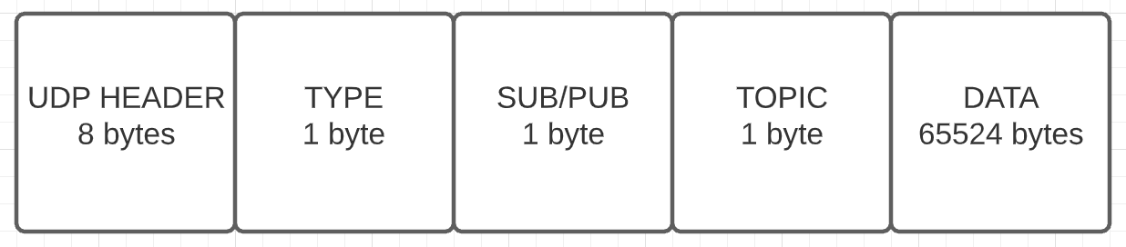

By default a Datagram Packet contains a UDP header which contains The destination address and port and the source address and port. In addition to the UDP header for the publish subscribe protocol I decided to include 3 more bytes of header.

1 Byte for the TYPE which indicates if the Packet is Data or an Acknowledgement (ACK). I decided to add this to the header so that we can distinguish between Data and ACK’s.

1 Byte for SUB/PUB which indicates if the Packet is Subscribing or Publishing. I decided to also add this to the header so that we can also distinguish between whether a packet is subscribing or publishing allowing the receiving node to simply check the packet header and decide what to do from there.

1 Byte for the TOPIC which indicates what topic the packet is subscribing/publishing to. Finally, I included this in the header to be able to distinguish between what topic is being published/subscribed to.

Then there are 65524 bytes remaining for the data section of the datagram packet for any data we want to attach to the packet

## Text Description automatically generatedSubscriber

The subscriber class is used by the broker to create subscriber objects and add them to a list. This helps the broker to keep track off which nodes have subscribed to what topics, so that when a packet arrives it just has to look at its list of subscribers and manage the packet accordingly (described in more detail in section 3.5).

The subscriber class consists of 3 variables, the port, address and topic.

## Packet

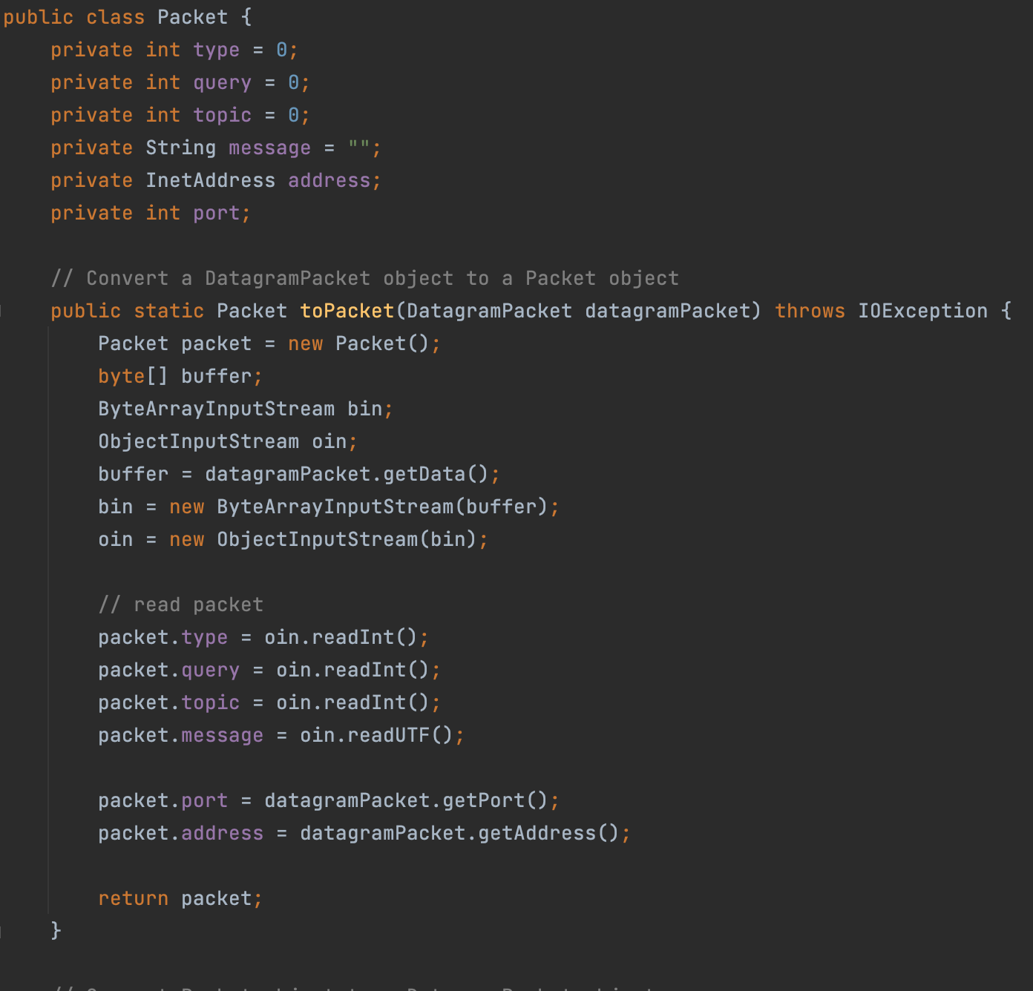

I implemented a Packet class so that I could have some static methods that I could use and adapt the datagram packet to the Packet described in 3.1. This enabled to make the code much neater and easier to understand. The Packet class stores variables that make up the packet, for example, type, query, topic, message, address and port. In the picture above we can see the method to Packet which converts a datagram packet to a Packet object using a byte array input stream and an object input stream to read the datagram packet, which enables the use of get methods to read the Packet for example the figure below:

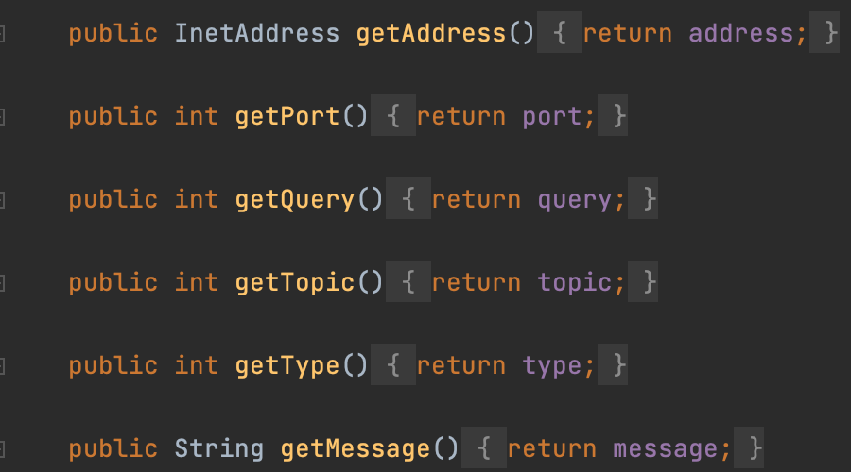

Packet also implements a method to convert a Packet back to a datagram packet, so that it can be sent to a node. In this method I used a byte array output stream and an object output stream to make the datagram packet. See picture below.

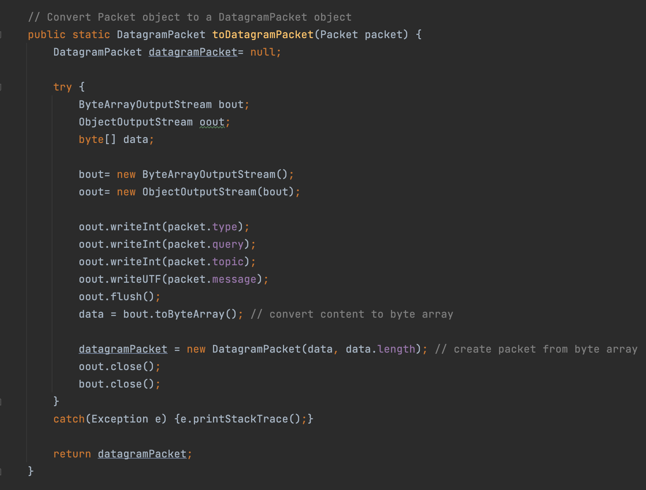

A method to receive a packet. See picture Below

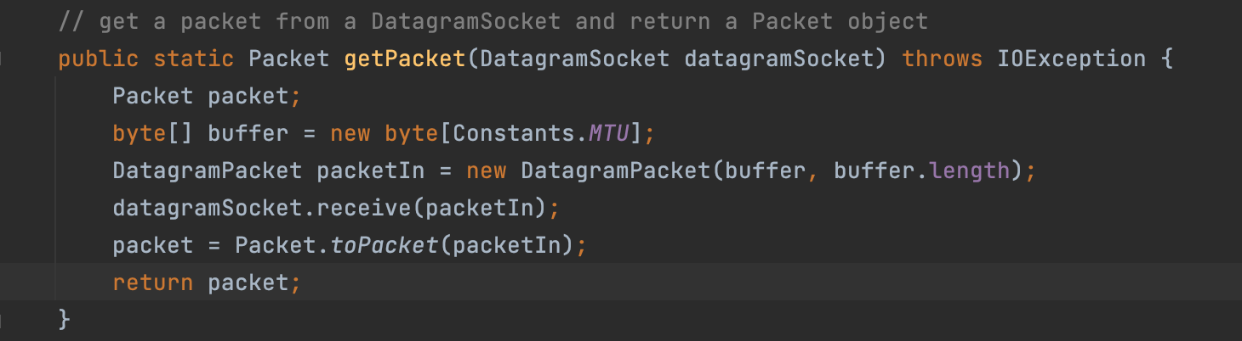

A method to send an ACK. See picture below.

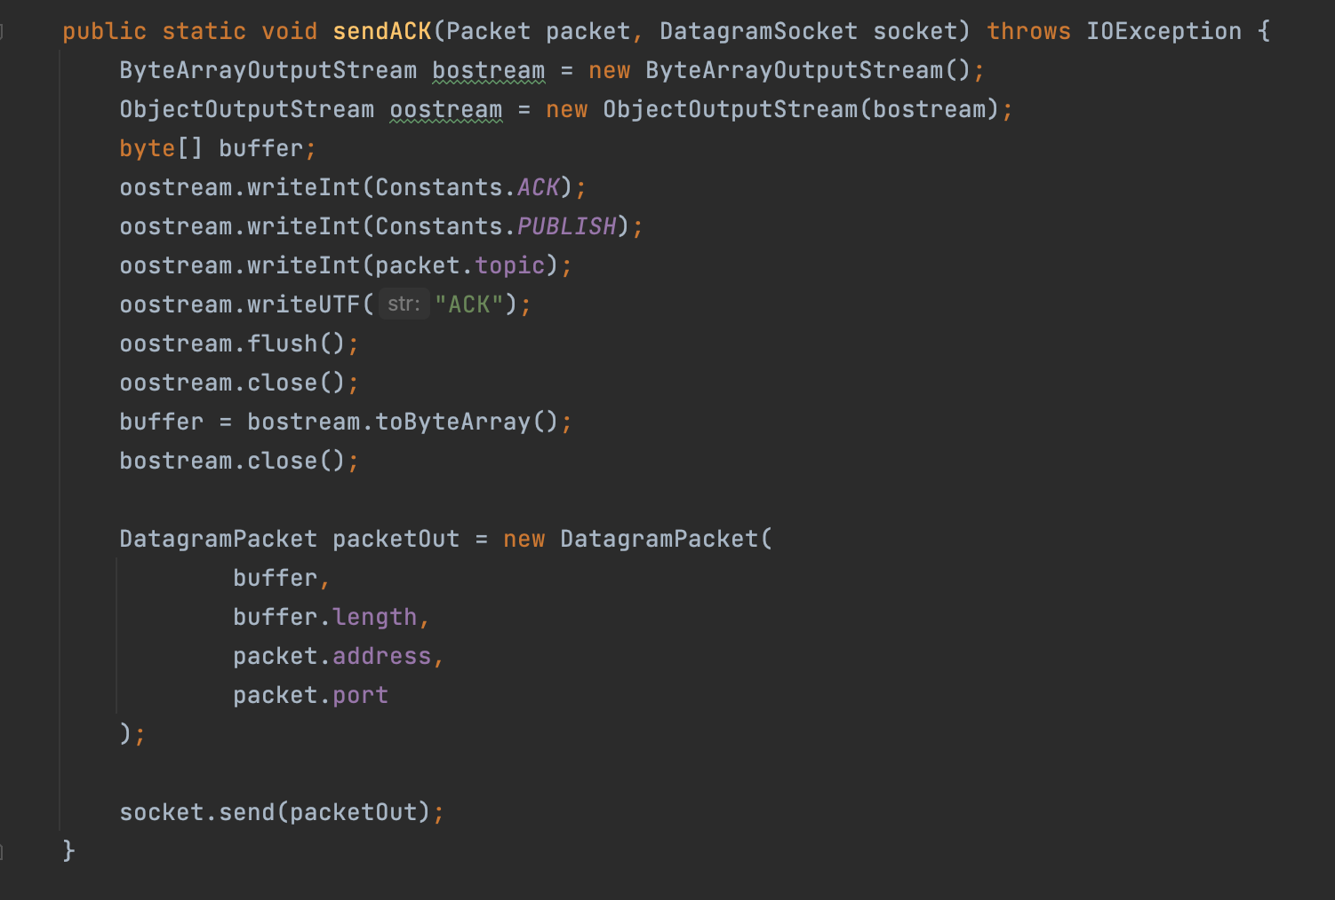

## Text Description automatically generatedDashboard/Dashboard2

Dashboard prints what is happening at every step, for example it will print to the console when it is subscribing to a topic, waiting for packets, sending an ACK or asking the user for input.

Using the method askQuery(), Dashboard first asks the user if it wants to subscribe or publish.

While the user selects publish we further ask the user which topic they want to subscribe to, and then ask the user to enter a command. Once the user enters a command dashboard publishes the command to the given topic using the userPublish() method.

When the user selects to subscribe we then ask the user to select a topic using the method askTopics() and then dashboard subscribes to the given topic by using the sendPacket() method indicating in the header what the packet is for, in this case when subscribing, the Type is indicated to be DATA, Sub/Pub is set to Subscribe, topic is set to the topic the user selected. In the data section of the packet we write a message that we are subscribing but it is not necessary to subscribe to a topic.

After subscribing the Dashboard will wait for incoming packets. When a packet is received an ACK is send back to the source node of the packet, then the packet is filtered down by reading their headers. If the packet is of type DATA then we will check if it is what we subscribed to, if it matches we print the data to the console, otherwise the packet is discarded. If the packet is an ACK we print to the console that we received an ACK.

## Broker

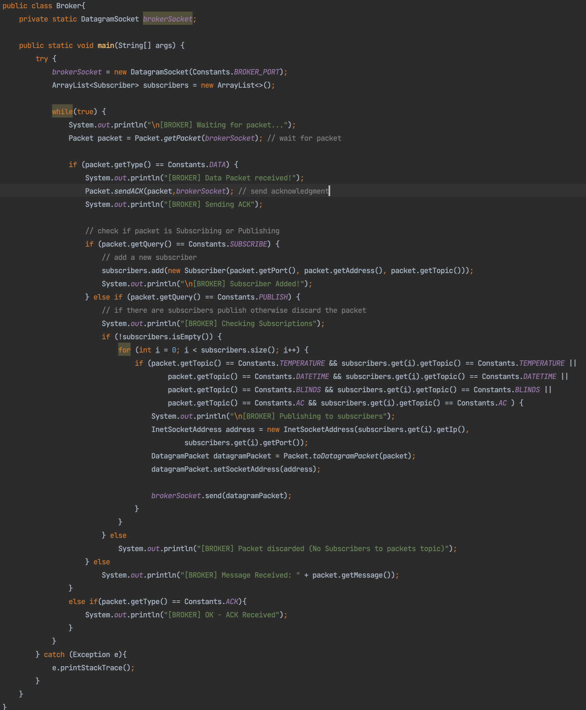

The broker class (see image above) waits for packets and then upon receiving a packet it sends an ACK back to the source of the packet. The is filters down the information in the packet to decide to what to do with the packet. If the packet is publishing, broker checks its list of subscribers to check if there are any subscribers to the packet topic. If it matches then it sends on the packet to the subscriber otherwise the packet is discarded. If the packet is subscribing then the source of the packet is added to its list of subscribers. It is in this way that the broker manages the packets in the topology described in section 2

## Sensor1/Sensor2/Sensor3

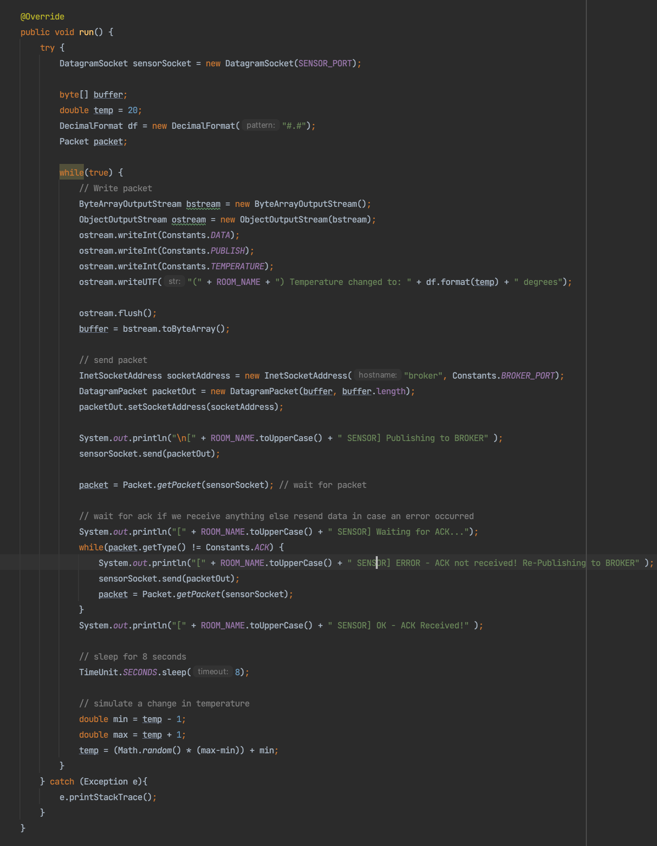

Sensor (see image above) implements runnable and hence I implemented the run method for sensor. In this method sensor writes a packet which contains the header DATA|PUBLISH|TEMPERATURE and then in the data section the room name and temperature is written. The packet is then sent to the broker and the sensor waits for an acknowledgement, if it receives anything that’s not an ACK it resends the packet. I then simulate temperature change by putting the thread to sleep for 8 seconds and generating a new temperature. I then make and run 3 sensor thread in a main method to make three temperature sensors.

## Blinds

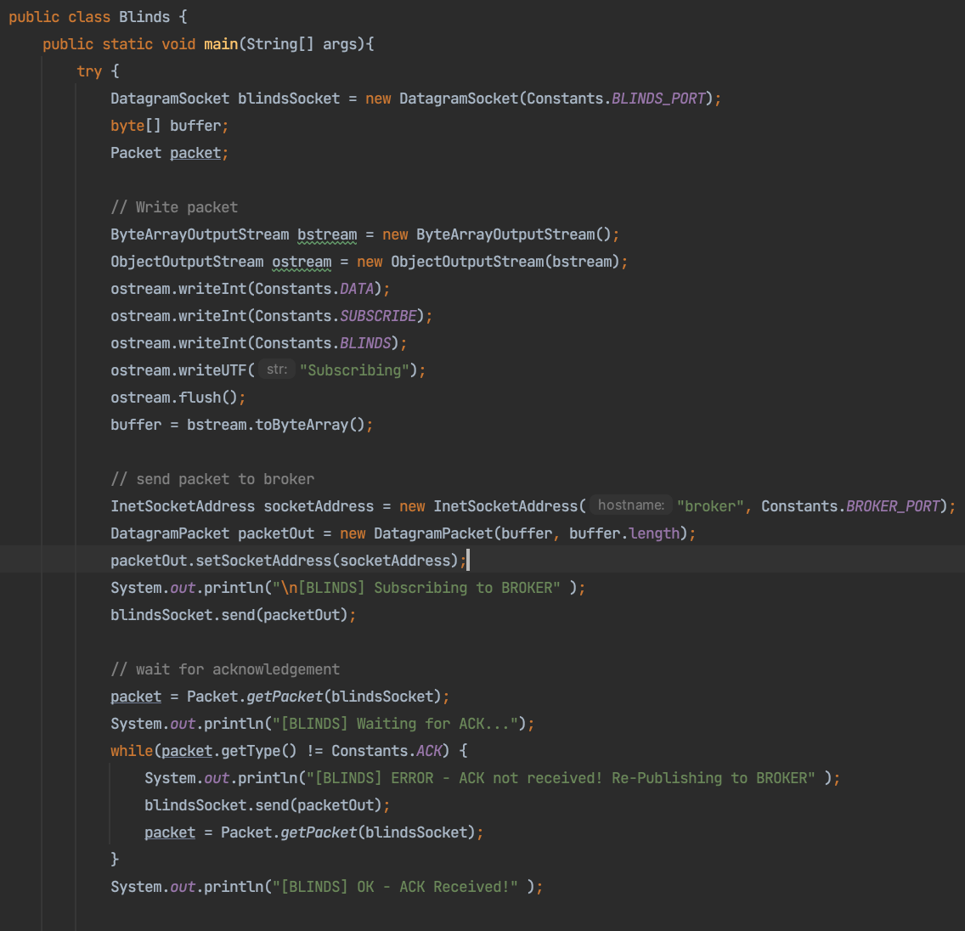

The blinds class (see image above) initially subscribes to the topic BLINDS by writing a packet with header DATA|SUBSCRIBE|BLINDS and sending it to broker. Blinds then waits for an ACK.

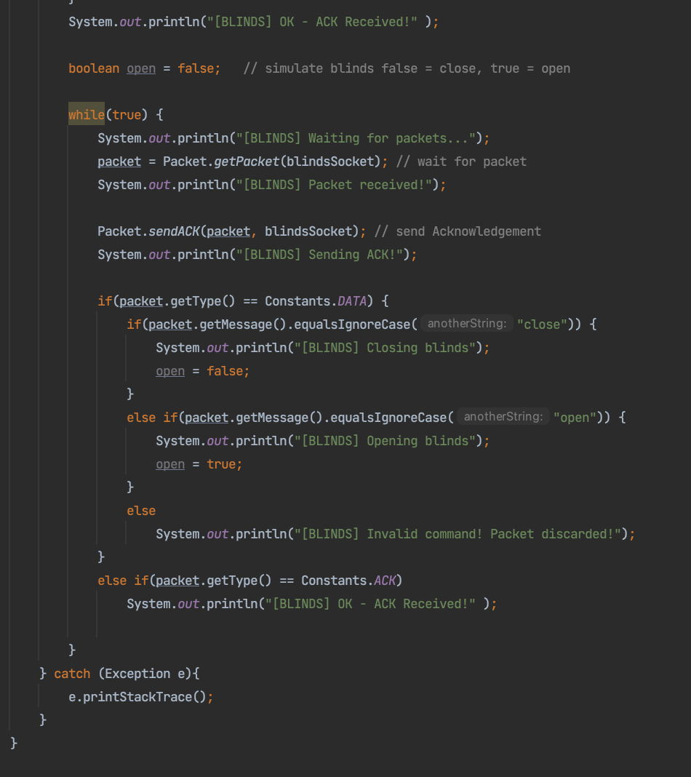

After blinds receives an ACK it waits for packets, when it receives a packet it sends back an ACK. Then blinds filters the packet to check if the packet is DATA or an ACK. If the packet is of type DATA then blinds checks the data section for a valid command and if the command open or close is present the blinds will open or close respectively. Otherwise if the command is invalid blinds discards the packet. (see above image)

## AC

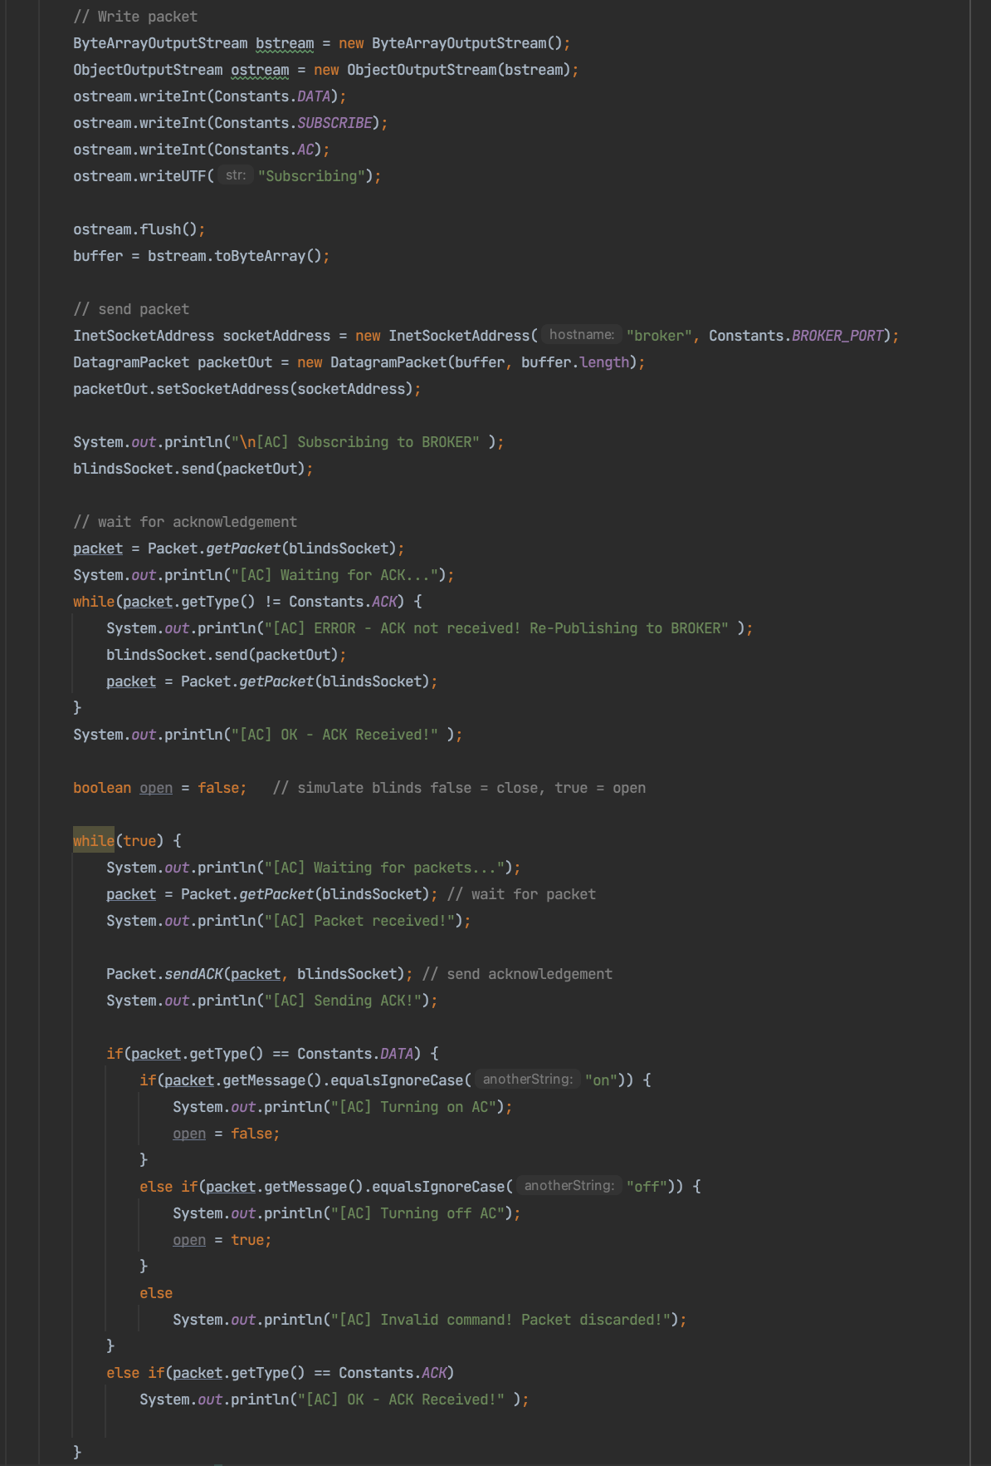

AC (see picture above) almost identical to how blinds work intsection 3.7 except that the commands are on or off to turn the ac on or off

## DateTime

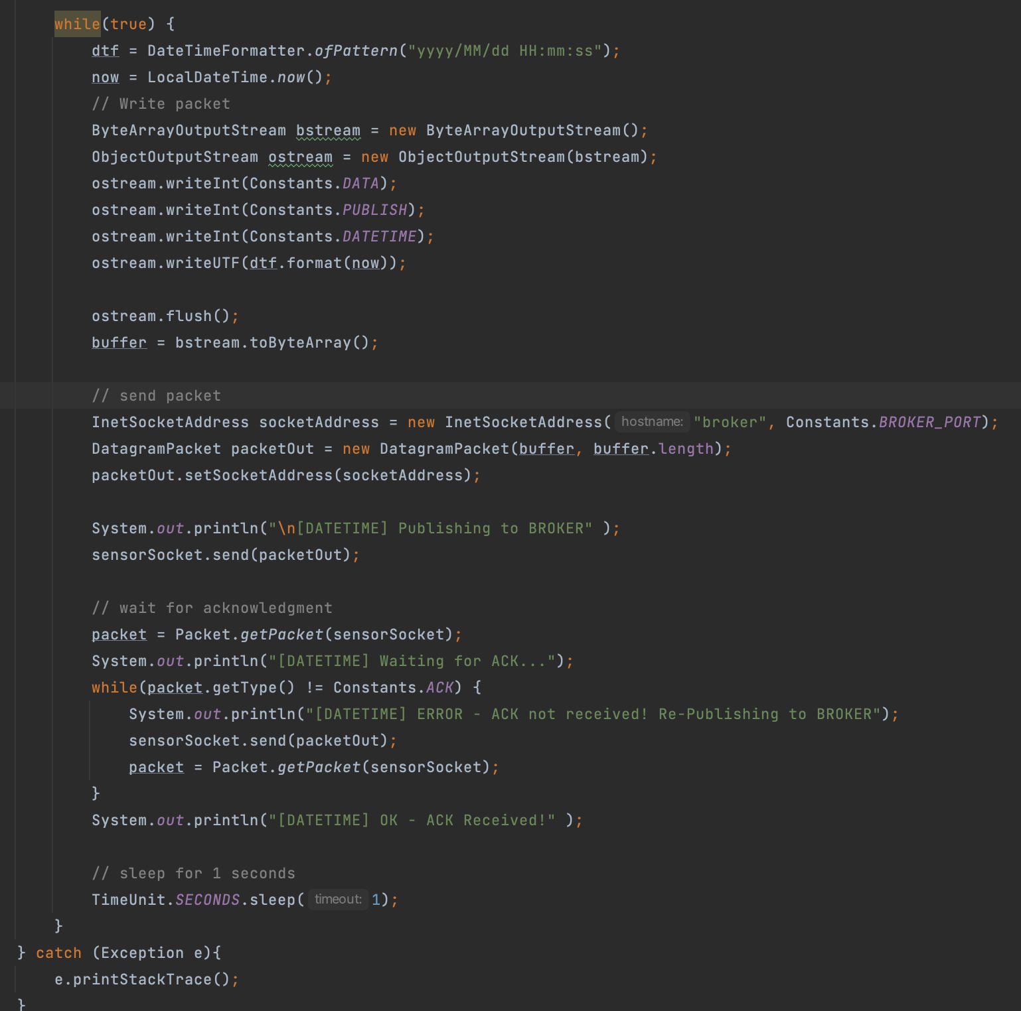

The class dateTime (see image above) writes a packet with the header DATA|PUBLISH|DATETIME and the current time every 1 second and sends it to the broker and waits for an acknowledgment.

## Constants

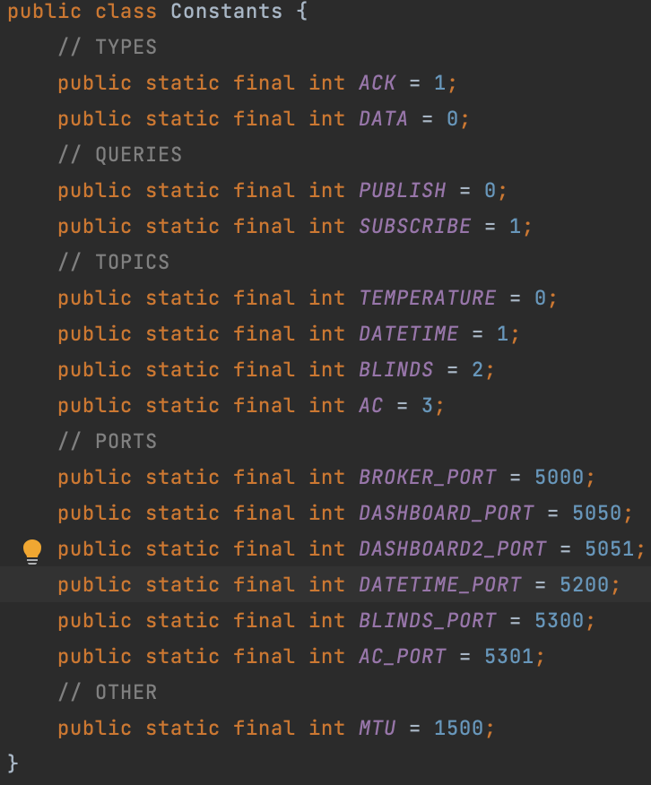

I made a static Constants class so that there is no redundant code in each class. Constants also keeps things nice and organised. Making it easier to read and understand the code.

## Interface

**Blinds and AC subscribing (image below)**

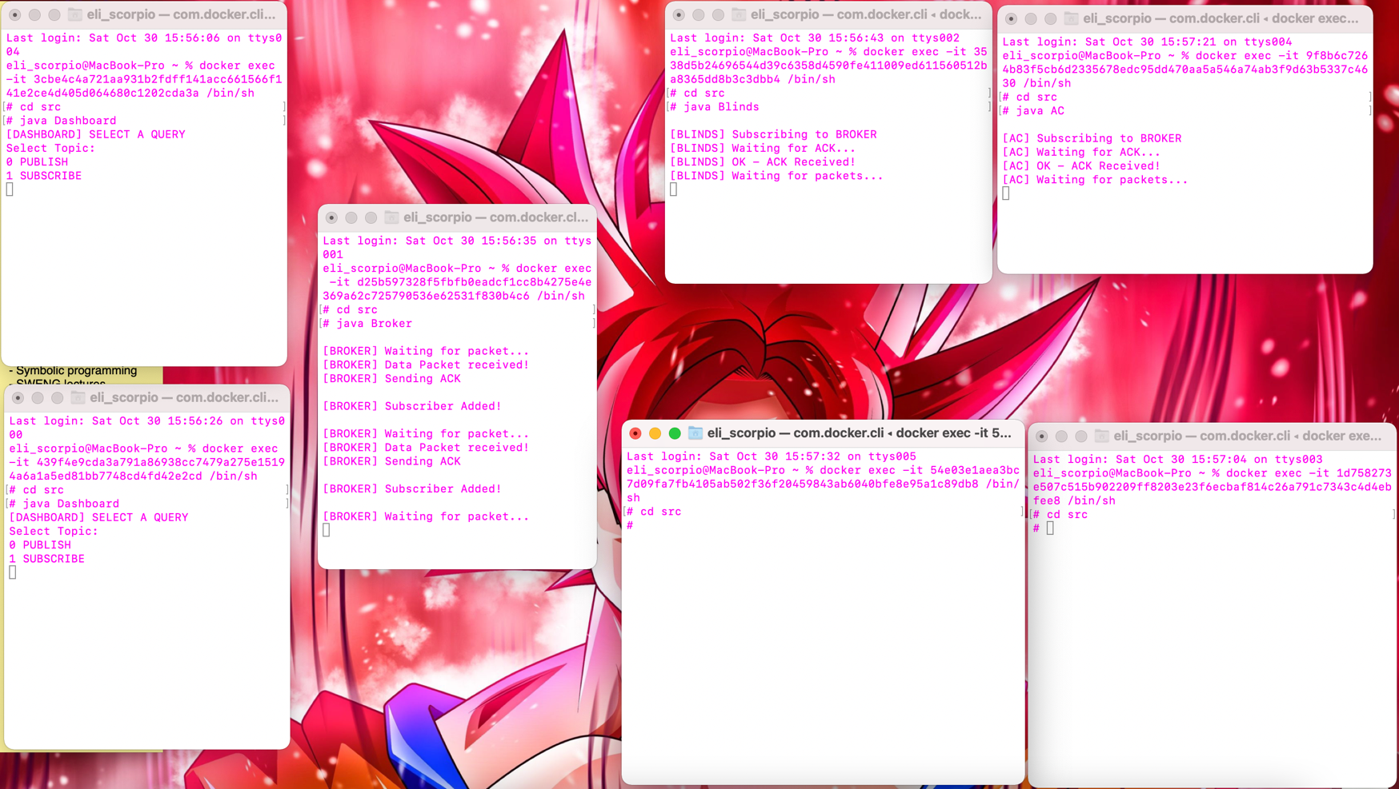

**Dashboard publishing open to topic blinds, dashboard2 publishing on to topic ac (image below)**

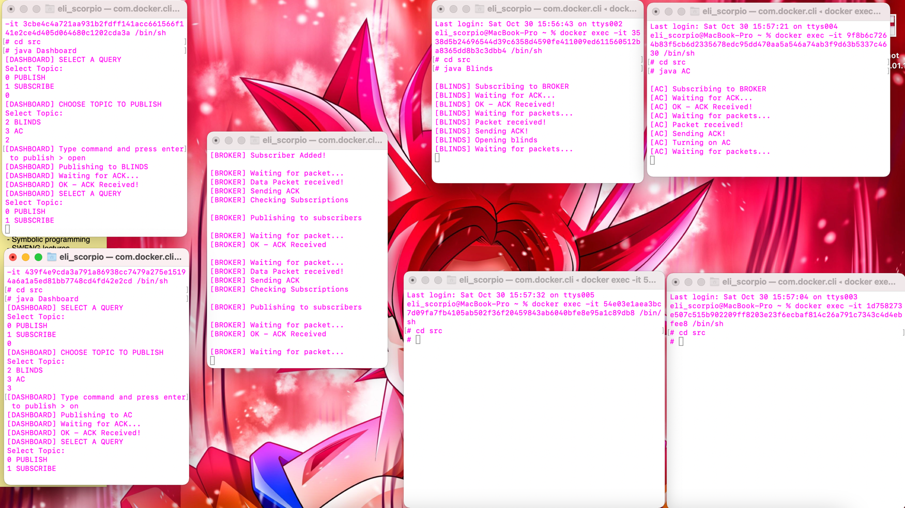

**Dashboard subscribes to topic Temperature, Dashboard2 subscribes to topic DateTime (image below)**

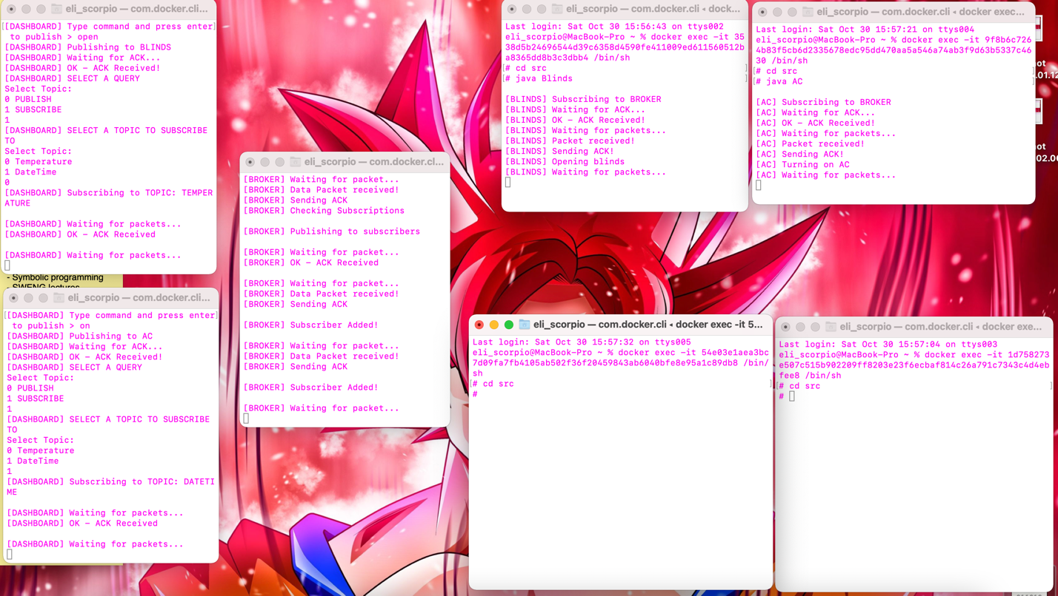

**Sensor publishes to topic Temperature, DateTime publishes to topic DateTime (broker publishes to subs) (image below)**

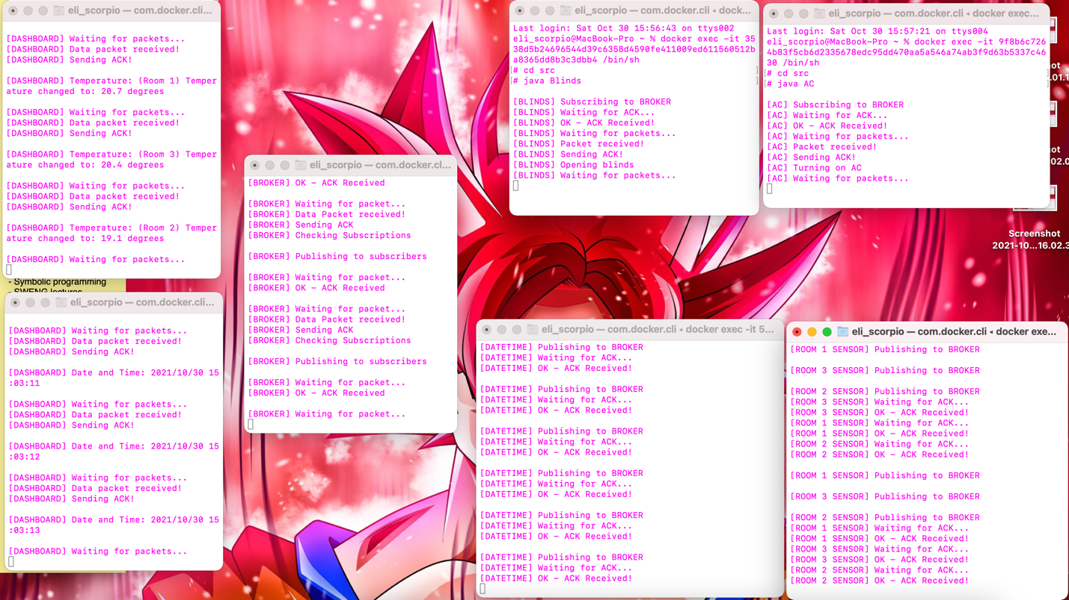

# Traffic

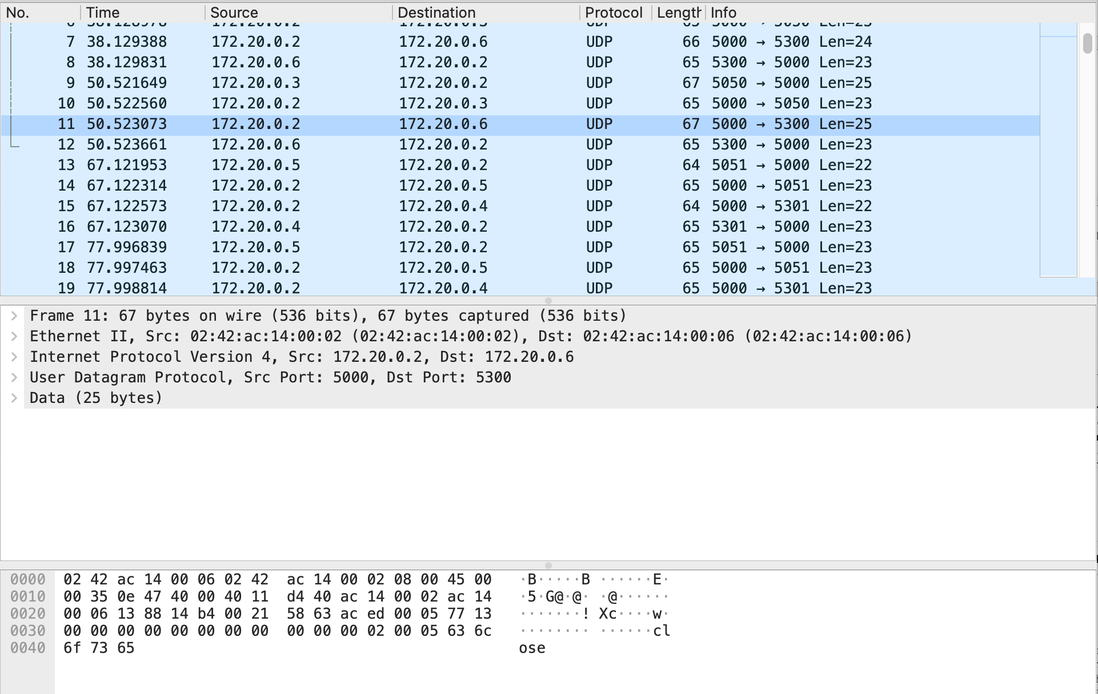

The picture above shows an example of the traffic when dashboard is publishing to the topic BLINDS

Line 9 dashboard sends packet DATA|PUB|BLINDS|”close” to Broker

Line 10 broker sends packet ACK|X|X|”ACK” to dashboard

Line 11 broker send packet DATA|PUB|BLINDS|”close” to Blinds

Line 12 blinds sends packet ACK|X|X|”ACK” to broker

# Assumptions

Some assumptions I have made in my assignment are that the packets are not prone to bit errors and burst errors. Hence there is no error handling implemented in my Publish/Subscribe protocol. I also have not implemented a timeout as I have assumed that a packet will arrive at eventually. I have made these assumptions because the adding error handling and an ARQ would require a larger header and make the protocol somewhat slower. For the purpose of this protocol from trial and error the packets did not seem to encounter errors and packet loss which helped justify my assumptions.

# Summary

In this report I described the theory behind the publish subscribe protocol, and the topology I implemented in section 2. I also described the overall design of the protocol and its interface in section 3. The report helps outline the important parts of the assignment and how I went about implementing them. It also describes what is happening in the network traffic via wireshark.

# Reflection

Overall I really liked this assignment as it challenged me in many ways. But with that challenge, I have learnt so much about socket programming, Datagram packets, Datagram sockets, the publish/subscribe protocol and the obstacles that you face when implementing a protocol. I was pleased that we had 6 weeks to do the assignment as it took a lot of pressure off and enabled me to learn the necessary knowledge to aid me in this assignment. In total I would estimate that it took me around 30 hours to complete this assignment as initially in the first 2 weeks I had very limited knowledge on socket programming and wrote code that wasn’t very good, hence I had to restart almost from scratch.